**Assignment 18.3**

**Problem Statement:**

Merge the small files in hadoop by following the below blog

<https://acadgild.com/blog/merging-files-hdfs/>

**Input:**

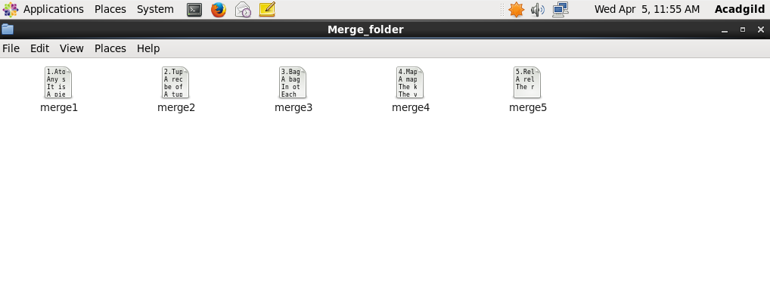

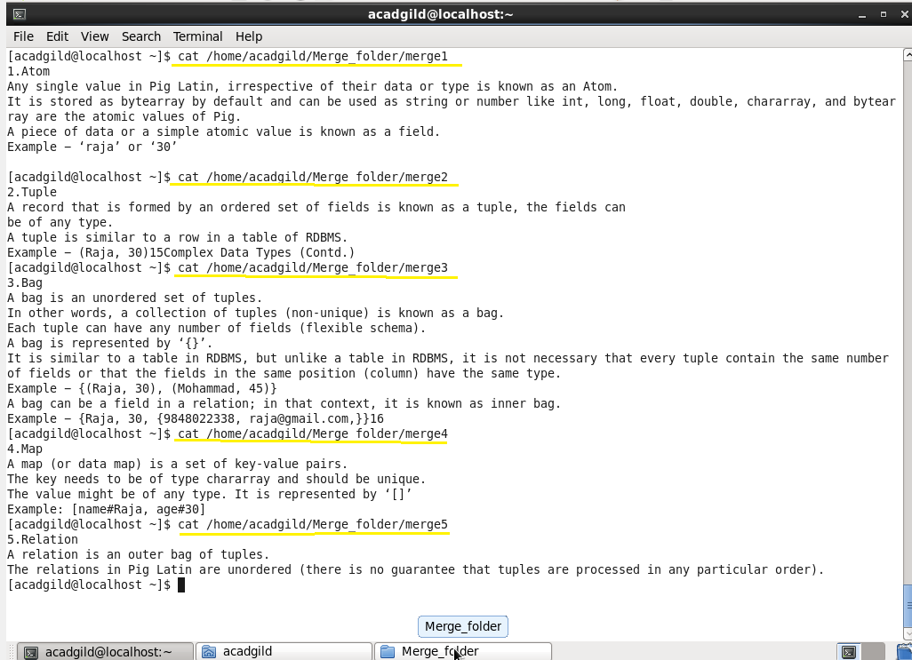

**Output:**

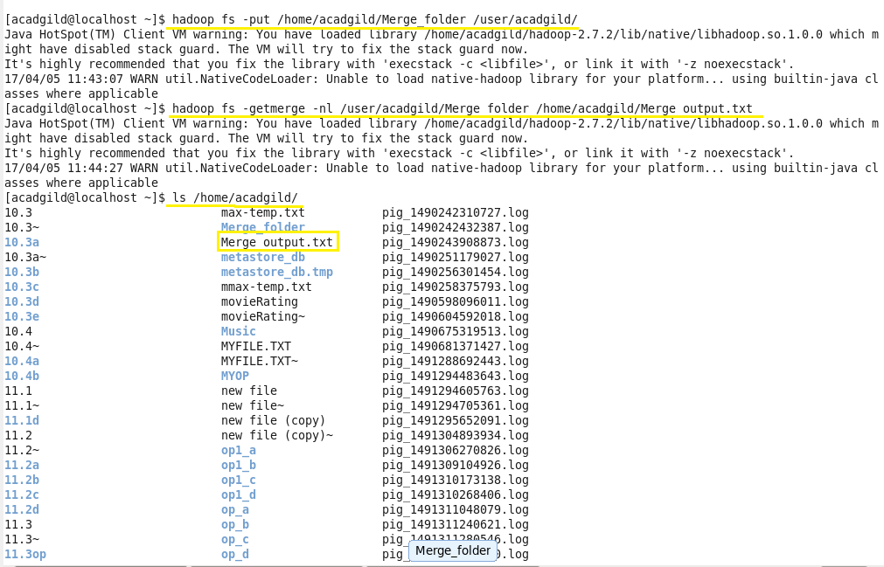

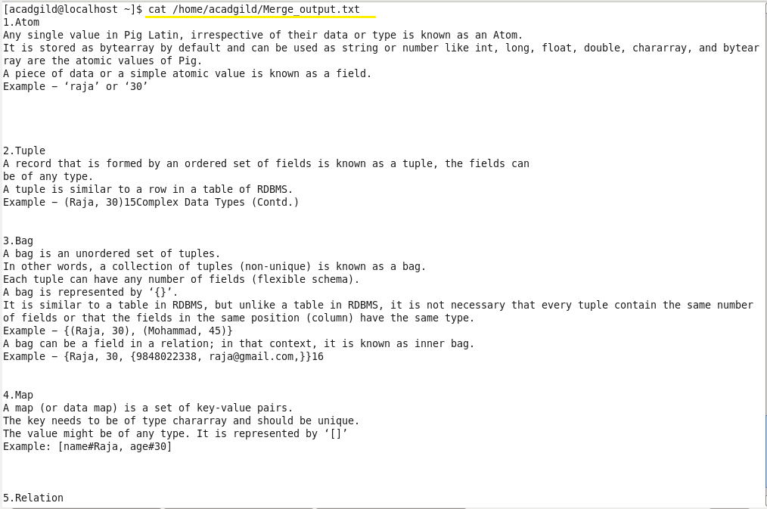

**C:\Users\612906\Desktop\assgn\18.3op3.png**